Performance Testing Phase

Date | 02-11-2025
Team ID | NM2025TMFD07309
Project name | Laptop Request Catalog item Using Service Now

Introduction:

The Performance Testing Phase is a critical part of the laptop evaluation process aimed at assessing the device’s capability to meet organizational performance standards and user requirements. During this phase, various tests are conducted to evaluate the laptop’s processing speed, multitasking efficiency, memory performance, battery endurance, and overall system responsiveness under typical and high-load conditions.
Purpose of Performance Testing:
The purpose of the Performance Testing in a laptop request through ServiceNow is to ensure that the requested laptop meets the organization’s technical and operational performance requirements before approval and deployment. This testing phase verifies that the device can handle standard business applications, multitasking workloads, and specific user demands efficiently without performance degradation.

Objectives:

- To facilitate efficient research, report writing, and project preparation.

- To access online learning platforms and digital resources for coursework.

- To improve productivity and timely submission of academic assignments.

- To enhance technical skills through the use of educational software.

Testing Procedure:

- Verify that the Laptop Request catalog item exists in the Service Catalog.
- Confirm that the correct variables are configured (e.g., laptop model, justification, accessories, cost center).
- Check that approval and fulfillment workflows are attached.
- Ensure test user accounts (requester, approver, fulfiller) are ready.

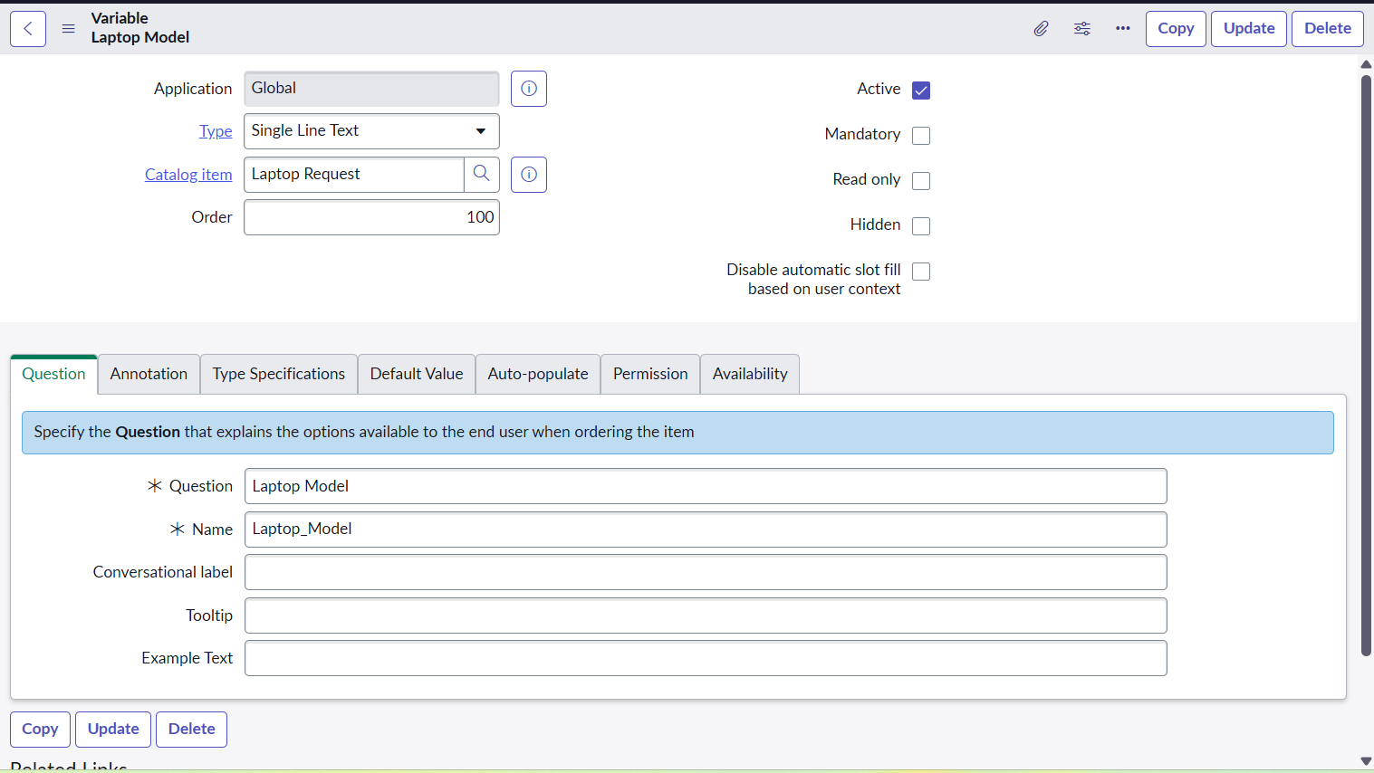

Ensure reports and dashboards reflect the request data.
Confirm that the request appears in:
  - Open Requests list
  - Fulfillment queue
  - Catalog Item usage reports

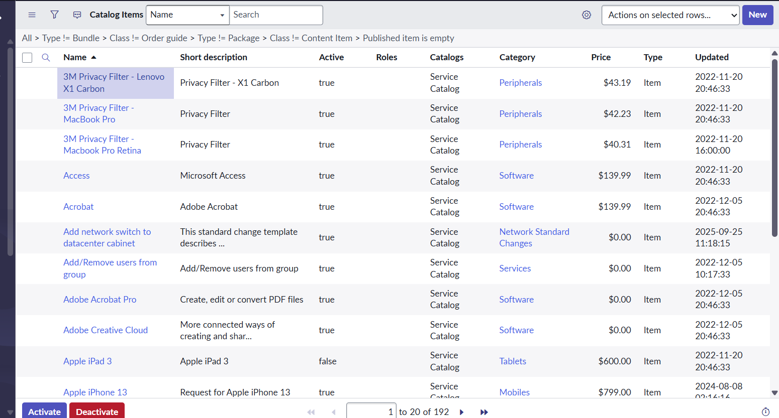

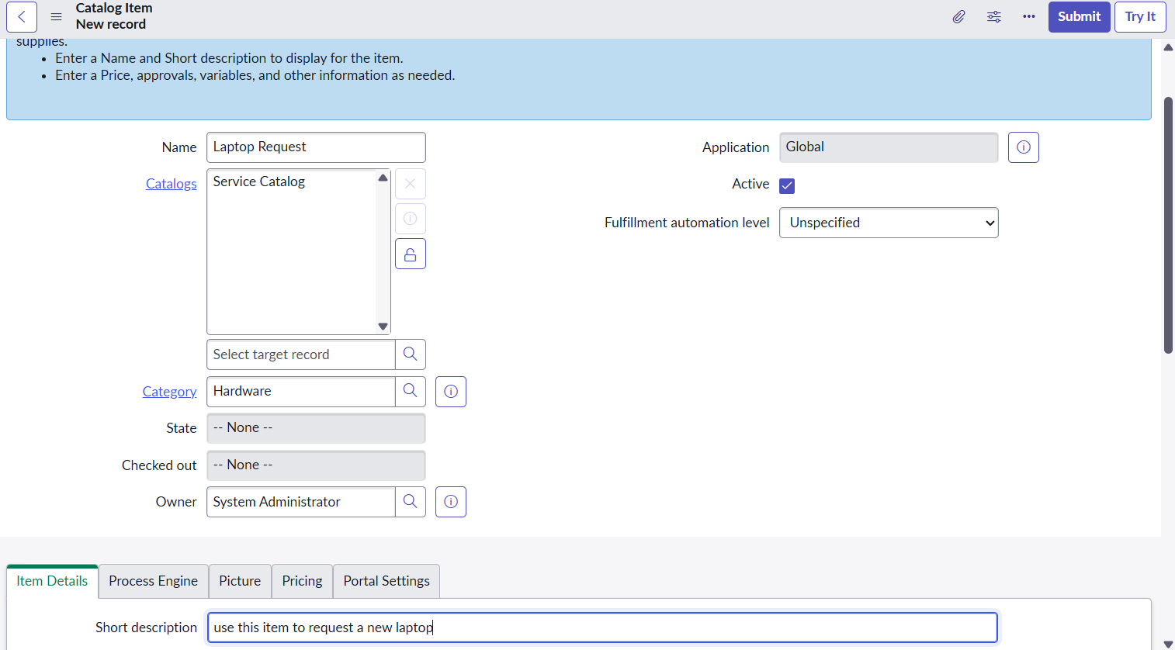

Results and Observations:

- The laptop request catalog item is visible and accessible to authorized users in the Service Catalog.
- The approval workflow correctly routes requests to the appropriate manager or department head.
- Email and in-system notifications are triggered accurately for requester, approver, and fulfiller.
- Fulfillment tasks are automatically created, assigned to IT, and closed properly after completion.
- Asset records are correctly linked in the CMDB, and requests appear accurately in reports and dashboards.

Conclusion:

The Laptop Request Catalog Item in ServiceNow has passed all functional and workflow validation tests.
The item is ready for production deployment or end-user release, pending final stakeholder sign-off.

